# The Early Childhood Inclusion Center of Excellence logo of just “us” in blue with the sun above it.

# SPARK: Simple Play Adaptations to Reference for Kids

## Busy Box Alternatives: Compact Activity Center

**Materials:** The Compact Activity Center is a small-scale, multi-use busy box type toy featuring a bead curtain, a vibrating light-up plate, a music box activated with a pull ball, and a spinning dome of brightly-colored sequins which helps with developing cognitive skills, teaching cause and effect, and increasing sensory stimulation. Busy boxes are commonly used by young children to explore a collection of colorful and varied textured objects that are stabilized to a board.

**Image:**

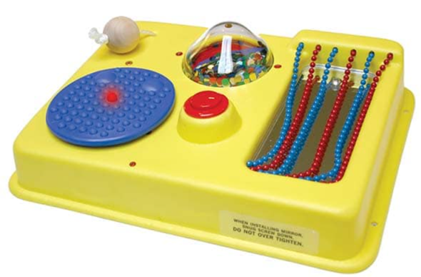

[Purchasing Information](https://enablingdevices.com/product/compact-activity-center/)

[Users Manual](https://enablingdevices.com/wp-content/uploads/2017/09/2300.pdf)

**Who Might Benefit?**

Those who…

1. Struggle or are frustrated by manipulating small objects.

2. Have limited mobility or ability to move into and out of various positions during play.

3. Need to further develop reaching, targeting, and eye hand coordination.

**Why Use?**

Provides an opportunity to…

1. Explore a collection of colorful, varied textured, and sound producing objects.

2. Engage in directed reach and fine motor activities.

3. Gain an understanding of simple cause and effect.

|  |  |
| --- | --- |
| **Instructions for Use:** | **Adaptation Ideas:** |
| **Environmental Considerations**   * Can be used in any environment including community, home and school. The product does have lights and sounds which may be disruptive in quiet environments.   **Positioning**   * **Tabletop:** Set up on a table or similar surface so the user can play while sitting. * **Floor:** Placed on the floor to use in a variety of positions such as tummy time position and side lying. * **Wall-mounted:** There is a wall mounted option for the Compact Activity Center that is not provided in this kit. It can be mounted on a wall using the four screw holes on each corner of the toy and the provided mounting hardware. Depending on the height of the mounting it can be used in a sitting or standing position particularly when encouraging reach without assistance and providing variety in visual display of a toy.   **Alternate Positioning**   * Can be used in any alternate position if the Activity Center is placed within easy reach of the child. * Slanted: Place on slanted surface such as a 3-4 inch 3 ring binder to help with viewing and reach. A slanted surface may help children view the toy or activity and/or reach the entire toy.   **Basic Play/Use**   * The Activity Center can be placed in front of the child within easy reach for free exploration of the various objects to support cause and effect learning.   **Extended Play/Use**   * Ask the child to touch and interact with specific activities (e.g. pull the ball, press the button, touch the beads, etc.). * Ask the child to reach to various colors to activate the activities (e.g. touch the red button, press the blue button, point to the blue beads, point to the red beads, etc.). * Ask the child to describe the texture of the object (e.g. the button is bumpy, the button is smooth, the button is vibrating, the sequins are spinning, etc.). * Ask the child to reach toward and touch objects based on the function of the object (e.g. touch the object that lights up, touch the item that vibrates, touch the item that makes music, etc.).   **Play/Use with Others**   * There are multiple items on the Compact Activity Center that would allow at least 2 children to play together either taking turns or engaged in parallel play. | **Optional Additional Materials/Supplies**   * Dycem * Sticky shelf paper * Velcro   **Stabilize It**   * If the child is having difficulty controlling their reach to the Activity Center, you could encourage the child to rest their forearm on the table while engaged in the activity which requires less control than using the entire arm. * Dycem could be used under the Activity Center to keep it in place on a table or Velcro could be use on the back of the Activity Center to attach it to the carpet if used on the floor.   **Simplify It**   * Some of the objects on the Activity Center could be covered with a dark cloth to limit the number of choices made available to the child for exploration. They can be revealed one at a time for full exploration of each item separately or they can be revealed in any combination.   **Contain it**   * There is a wall mounted option for the Compact Activity Center that is not provided in this kit. It can be mounted on a wall using the four screw holes on each corner of the toy and the provided mounting hardware.   **Add Sensory Cues**   * All items on the activity center have unique tactile cues either through texture or the touch exploration and interaction with the activity. Additional stickers, puffy paint, or other tactile cues could be added if needed.   **Communication Support**   * Provide a communication board with vocabulary appropriate for the various Activity Center activities  (e.g. more, I like …., stop, help, etc.).   **DIY Alternatives**   * [Build a toddler busy board with items you already have](https://www.familyhandyman.com/article/build-a-toddler-busy-board-with-items-you-already-have/). |

|  |
| --- |
| **Additional Considerations:**   * For children with auditory sensitivities, it should be noted there are sounds that accompany most of the activities on the Compact Activity Center. * For children with visual sensitivities, select items on the activity centers could be covered to reduce visual distraction or sensitivities. * Requires 2 C Batteries. Size: 23½"L x 12½"W x 10½"H. Weight: 3½ lbs.   **Ohio Early Learning Standards:**   * AL: Engagement and Persistence: Engages in new and unfamiliar experiences and activities (1.a.). * AL: Engagement and Persistence: Persists in completing a task with increasing concentration (1.c.). * CO: Problem Solving and Reasoning: Develops ability to be flexible in own thinking and behavior (4.a.). |

### Words to Encourage Play/Use

|  |  |  |
| --- | --- | --- |
| **Push**  Child pushing rock away. | **Pull A child pulling a rock toward them.** | **Reach**A child reaching for a red cube. |
| **Touch**A child with their hand on the shoulder of another child. | **Help**A child kneeling on his knee and another child reaching toward the kneeling child. | **LikeA hand giving a thumbs up** |
| **StopRed light lit up on a traffic signal** | **GoGreen light lit up on a traffic signal** | **MoreA pile of red stones with a black arrow pointing to the top and a smaller pile of red stone next to that pile.** |

*”Adaptations” adapted from: Haugen’s Modes for Adapting Toys based on materials from the "Let's Play" Project at the University of Buffalo

***PCS is a trademark of Tobii Dynavox, LLC.  All rights reserved.  Used with permission*.**

